Audio Recording FAQs 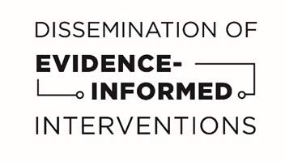
- Why do you want to record my conversations?
  - The audio recordings will be reviewed to make sure that we are providing services that address patient needs and will help us to identify opportunities to strengthen the way we provide services to you. The recordings will be used to learn more about the services you may need, and will help me to improve at my job.

- Who will listen to the recording?
  - There will be 3 people who will review your recordings. These 3 people have human subjects training and are ethically bound to not disclose any of the information that they hear on the recording.

- I don’t want people to know my HIV status.
  - The audio recordings are confidential. The people who are reviewing them will not know your name or any other identifying information about you. They will not be able to link your name to your recording.

- How long will they have the recording?
  - All recordings will be completely destroyed and deleted from any systems 12 months after they have been uploaded into the secure, password protected site at Boston University. Boston University will keep them for a maximum of 12 months but they may delete them earlier than that.

- Do I have to be recorded?
  - You do NOT have to consent to be recorded in order to participate in the evaluation (the baseline and follow-up) or to receive intervention services. Even if you do consent to participate in audio recording, you can always choose not to be recorded for one session, or part of a session. If you do not consent to be audio recorded, it will not affect the social services or medical care that you receive.

- When will I be recorded?
  - Each month, we receive a random sample of patient ID numbers to record over the course of a month. Your number may be on our list for one month or may never be on our list – again, it is a randomly generated list. Once we get that list, your care coordinator will let you know that they would like to record their interactions with you during that month. The number of times that you are recorded will depend on the number of times that you meet over the course of the month.
  - You will only be recorded when you interact with your care coordinator after you are released. We will not record any meetings that take place in jail.

- How do the recordings work? What will happen when I am recorded?
  - Your care coordinator will use a handheld audio recorder to record your in-person conversations. The care coordinator will ask for your permission again before each and every session where they plan on recording, and you can always decline to have that conversation recorded. They will then upload that file to a secure online computer system to share the file with Boston University, who will review the audio file.

