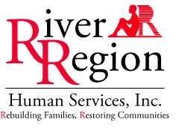

Congratulations! You have successfully completed the PATH program requirements. You are now on the PATH towards becoming self-sufficient, healthier living and are now more aware of the social and medical services available in Jacksonville, Florida.

Please keep the following information handy should a medical or social need arise. The list below is a primary resource to services you are connected to. Please be sure to check your RW and/or ADAP expiration dates often (renewal is every 6 months).

Primary Care Provider: _____________________________________________________________

Specialty Care Clinic/Provider: ___UF CARES 904-XXX-XXXX_________________________________

Case Management Agency/Case Manager: _____________________________________________

Mental Health Services/Substance abuse:______________________________________________

RW and/or ADAP: _________________________________________________________________

Food Pantry: _____________________________________________________________________

Dentist: _________________________________________________________________________

Thank you for allowing the PATH team to assist you. It has been a privilege to get to know you and work alongside you. The PATH team wishes you much success and hope in the future.

__________________________________________ _____________________
Patient signature Date

