Housing Status Tracking Database
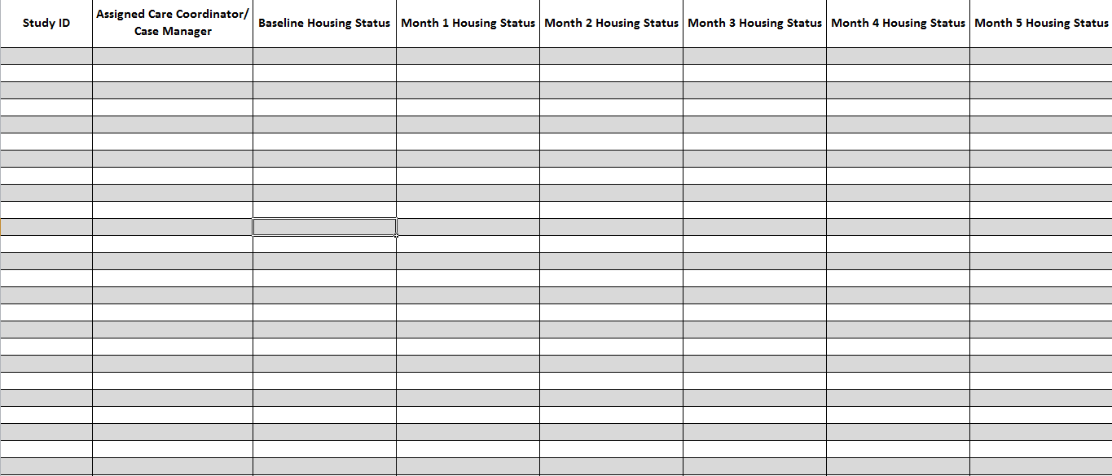

Response Options:
- Out of Contact/ Unknown
- Moved
- Housed
- Unstably Housed
- Treatment, Respite, Hospitalized
- Jail/Prison

This publication is part of a series of manuals that describe models of care that are included in the HRSA SPNS Initiative Building a Medical Home for HIV Homeless Populations. Learn more at http://cahpp.org/project/medheart/models-of-care

