Motivational Interviewing Supervisor Observation Form
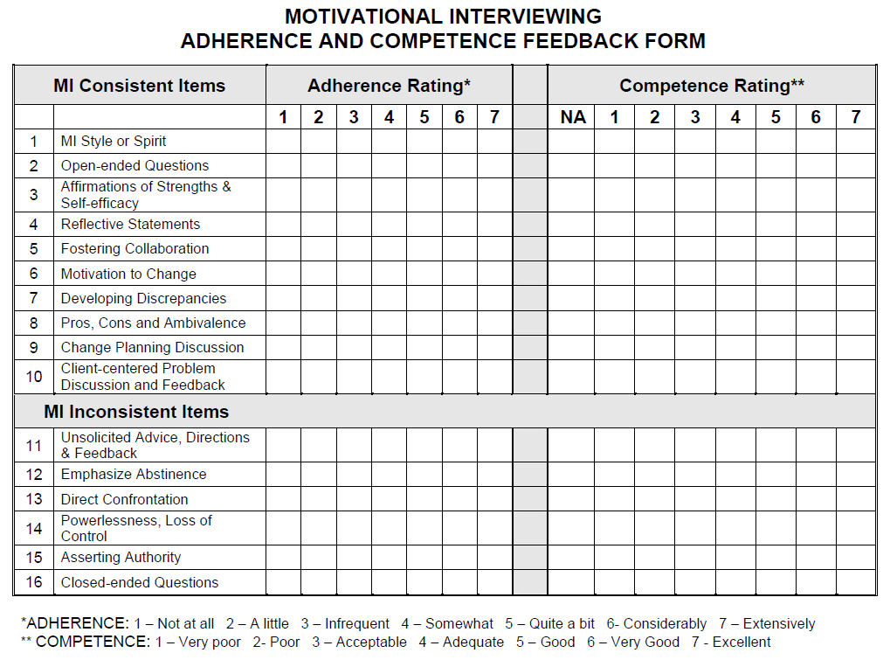

Addiction Technology Transfer Center Network (funded by Substance Abuse and Mental Health Services Administration SAMHSA), Motivational Interviewing Assessment: Supervisory Tools for Enhancing Proficiency (MIA:STEP), http://www.attcnetwork.org/explore/priorityareas/science/blendinginitiative/miastep/product_materials.asp

Motivational Interviewing Supervisor Observation Form
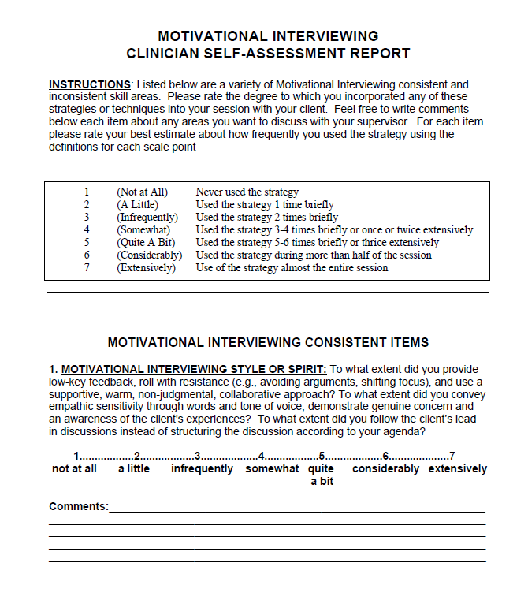

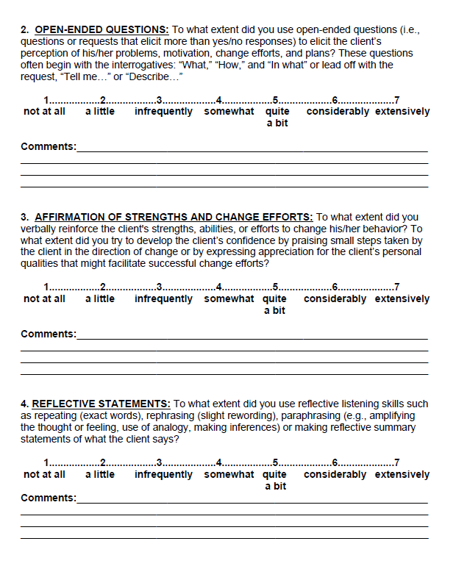

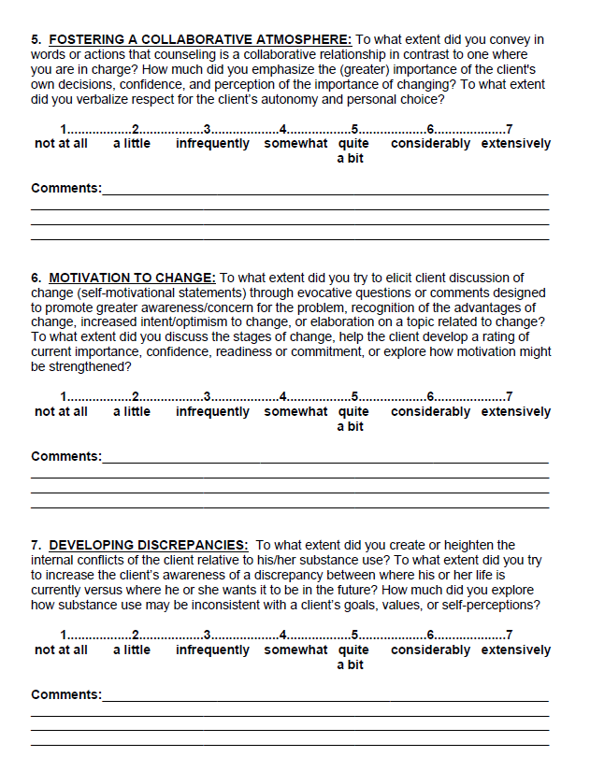

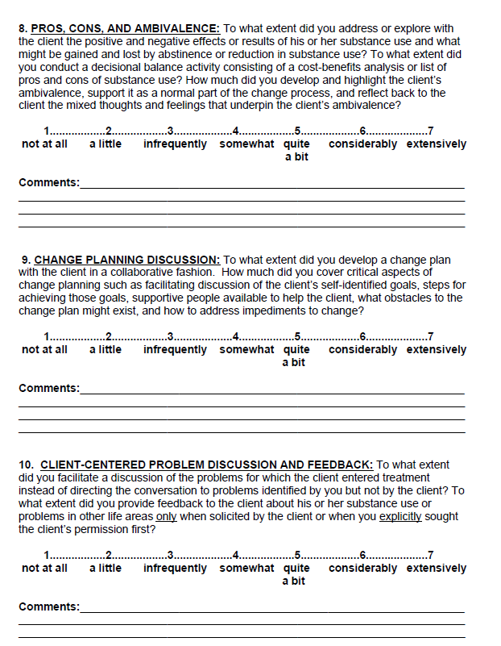

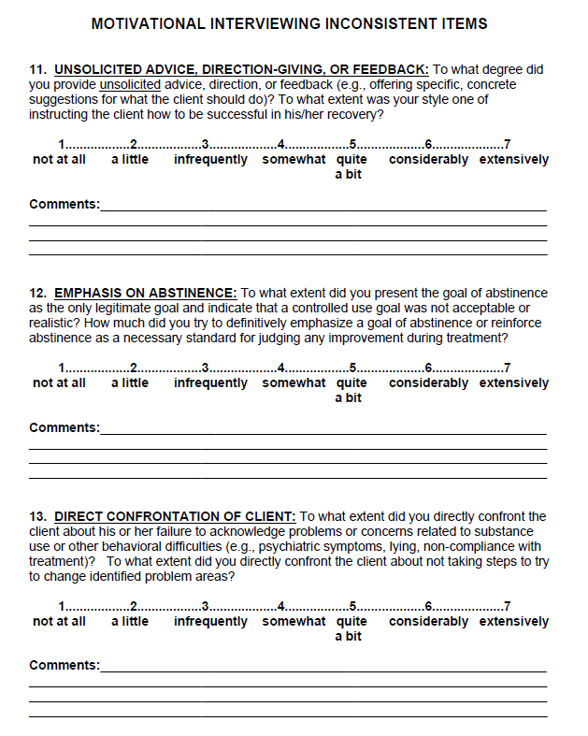
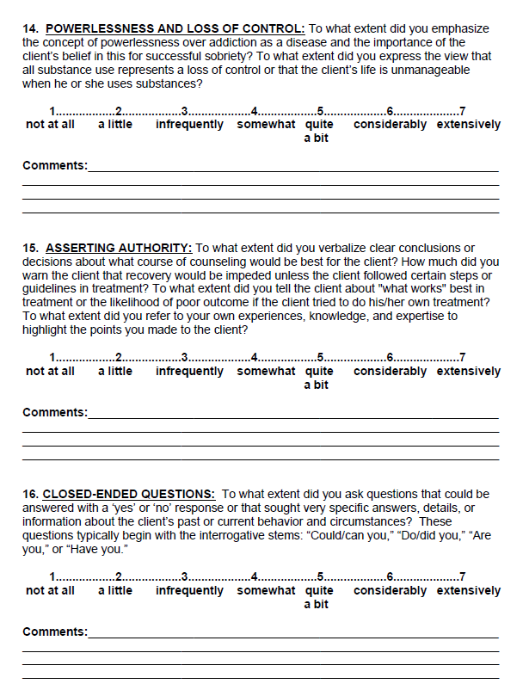

This publication is part of a series of manuals that describe models of care that are included in the HRSA SPNS Initiative Building a Medical Home for HIV Homeless Populations. Learn more at http://cahpp.org/project/medheart/models-of-care

