EHR modules: Sample Encounter Note with Acuity Worksheet

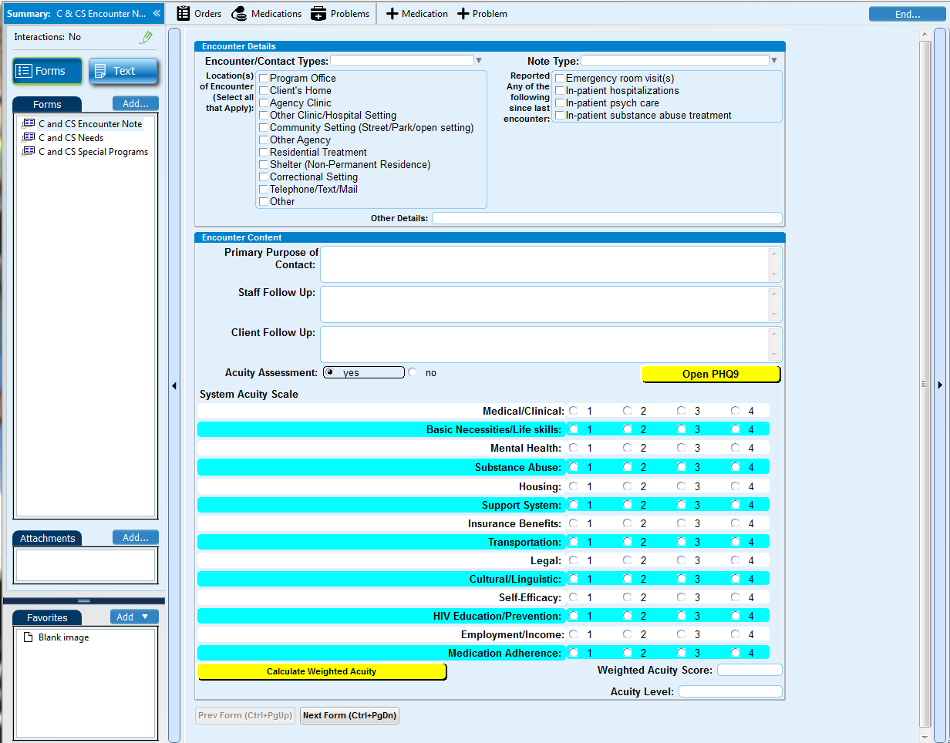
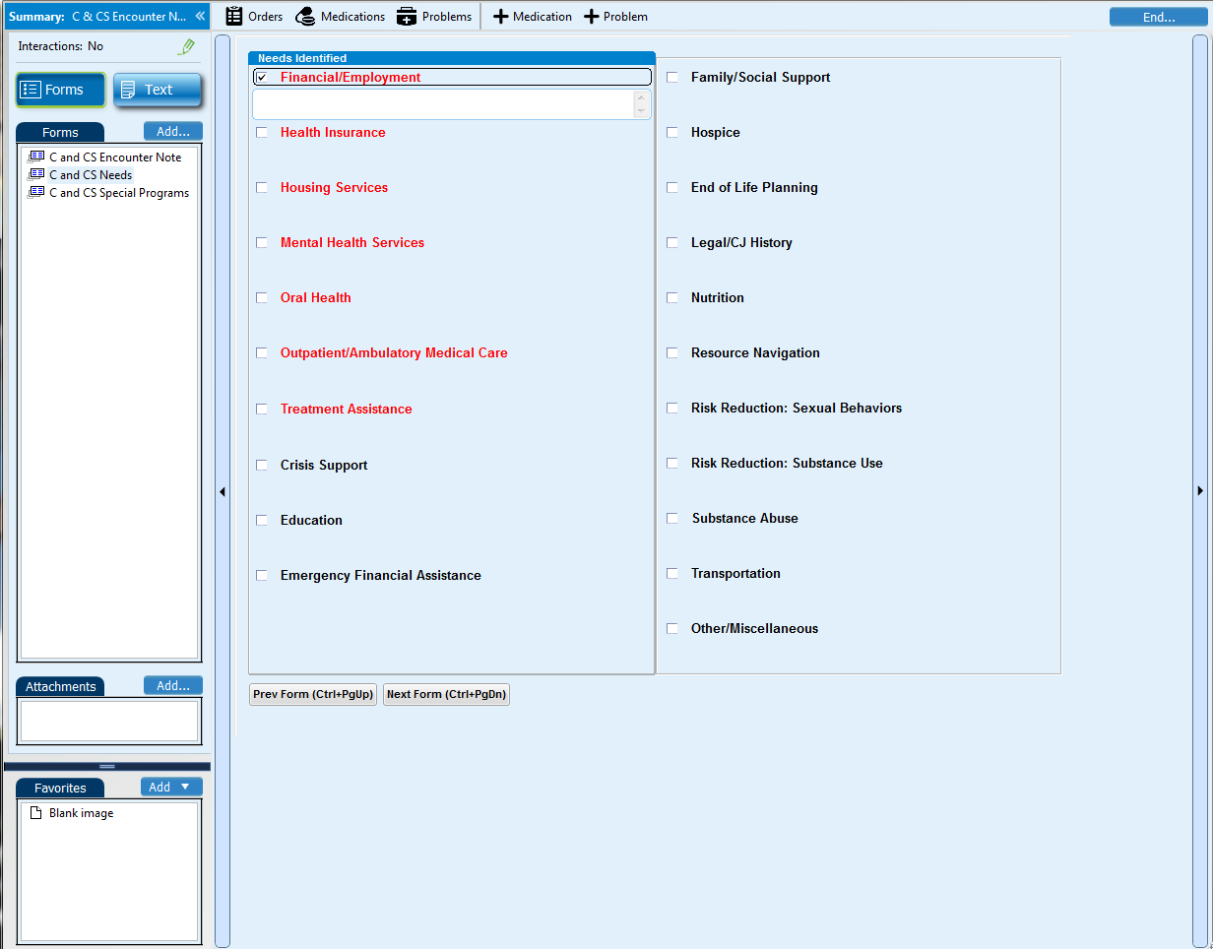
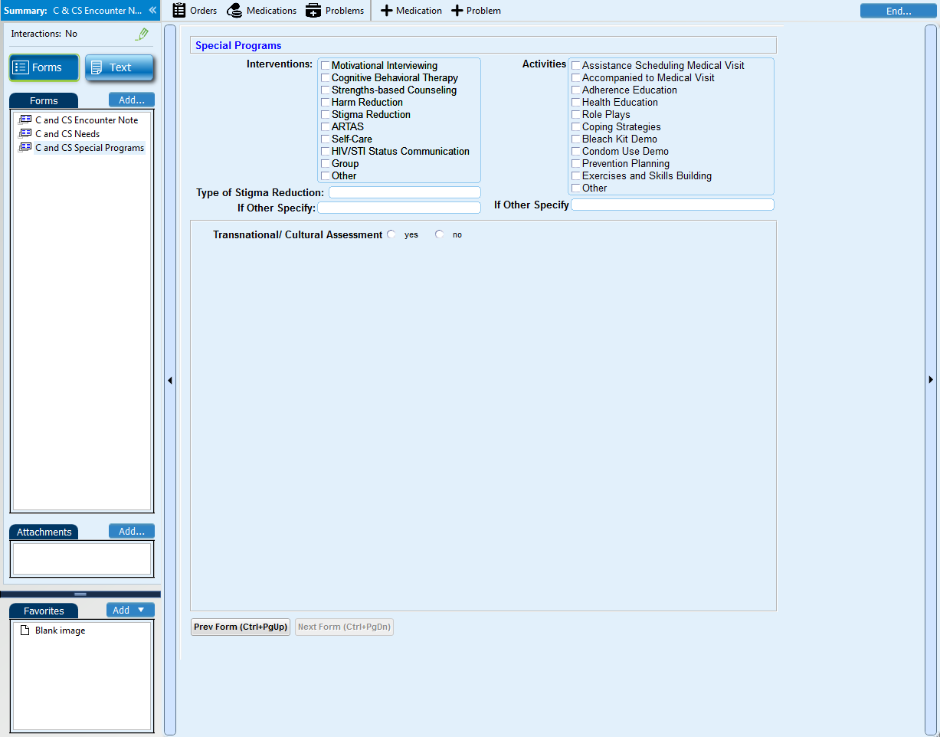

This publication is part of a series of manuals that describe models of care that are included in the HRSA SPNS Initiative Building a Medical Home for HIV Homeless Populations. Learn more at http://cahpp.org/project/medheart/models-of-care

