Housing Guide:
tips and tools for a successful housing experience

Letter from Barry and Jim

Getting started check list:
Have you met with your landlord?
Name: _____________________________
Contact Information:
___________________________________
___________________________________
Do you know how to control your thermostat?
Do you have a payment plan?
Do you know which bills you need to pay monthly?
Examples (electricity, heat, hot water)
List them here:
__________________________________
__________________________________
For information on payment assistance programs visit:
- https://www.pseg.com/home/customer_service/bill/help/payment_assist.jsp
Do you have a spare key?
Does your landline work?
Have you checked what amenities are included?
(ie. Stove, microwave)
Do you have a list of emergency phone numbers?
List Emergency Numbers here:
___________________________________

___________________________________

___________________________________

~ TABLE OF CONTENTS ~

How To Settle In……………………………………page 1
How To Stay Connected to Family and Friends……page 2
How To Stay Safe………….……………………… page 3
How To Keep Rooms Clean……………………….page 4
How To Buy Groceries and do Laundry………………page 5
How To Keep Track Of Appointments And Bills……page 6
How To Keep A Weekly Schedule………………………page 8
How To Set And Keep A Budget And Open a Bank Account…..page 7
How To Write A Check……………………………………page 9
How To Get A Photo ID………… ………………page 10
How To Get A Library Card……………………………...page 11
How To Set Up An Email Account…………………….page 12
How To Be Informed About Your Record……………page 13
For More Information……………………….page 14
Weekly Meal Planner Template……………………page 15

How To Settle In
MAKE YOUR PLACE YOUR OWN
Now that you have a place, you may need to get furniture, utensils and other supplies to help you get settled in your new home.

Massachusetts Coalition for the Homeless Furniture Bank is an excellent resource for getting the essentials, such as couches, chairs, tables and bedframes.

They distribute for free. To visit the furniture bank warehouse you can make an appoint online at http://mahomeless.org/programs/furniture-bank
- Appointments take place Monday-Friday 9am-3pm.

Visit http://www.furniturebanks.org/list-of-furniture-banks/ to find a list of other furniture banks in your area.

The Dollar Tree can also be a great place to get household basics, such as sponges, reusable bags, and cups inexpensively.
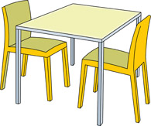

ROOM ESSENTIALS
Room Essentials
Kitchen | Bathroom | Bedroom
Plates, utensils, pots and pans, dish soap, sponges, trash can, trash bags, dish towels, dish rack, paper towels, cleaning products | Soap, shower curtain toilet brush, plunger, trash can, cleaning products, toilet paper, towels | Sheets, blankets, curtains, pillows, hangers
How To Stay Connected To Family & Friends

GET INVOLVED
1. Community Centers and Drop in Centers.

The YMCA serves as a place where you can exercise while also being social.

The YMCA provides financial assistance based on demonstrated need.
- For more information talk to your case manager
2. Find AA and NA Meetings.
Use these meetings as a way to meet people and gain contacts.
Get telephone numbers at meetings.
3. Be a friendly neighbor.
Make an effort to get to know your neighbors. Say hello and introduce yourself when you have the opportunity.
4. Volunteer!
Look for volunteer opportunities. Hospitals, churches, and animal shelters are great places to start!
You can find volunteer opportunities online (at the library).
SET YOURSELF UP FOR SUCCESS
1. Have Phone Numbers.
Before moving in make sure to have phone numbers of friends and family that you may want to contact. Also keep the number of the pharmacy and your doctor on hand so that you can easily call for a prescription.
Keep a list of these phone numbers and other important numbers somewhere easy to access, like your refrigerator.
2. Use Online Resources.
Check online for support groups of other people in similar situations. Do not be afraid to reach out.

*The library can be a great place to find community activities, to volunteer and is a great way to gain access to the internet or a computer*
How To Stay Safe

Copy Important Documents.
- Make a copy of your ID or license, social security card, medical card and other important papers (copies can be made at the library)
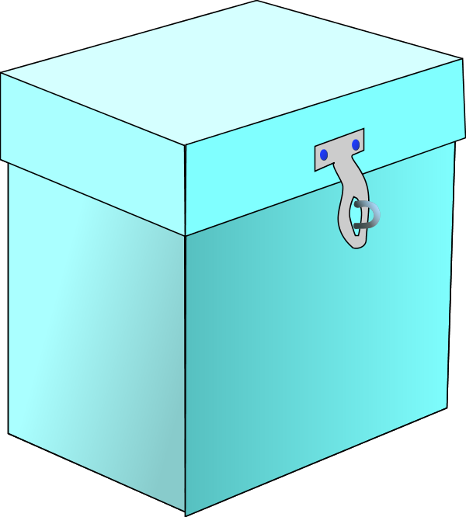
- Find a place for valuable papers.
- Use a lock box, which can be purchased at Target or Walmart or a
file cabinet that locks to store valuable papers
BE PREPARED
- Use a file folder or manila envelope until you can get a locked unit

1. Have An Exit Strategy.
- In case of an emergency have at least two planned ways of exiting the building.

2. Have Emergency Supplies.
- Keep a bag packed with essentials in case of an emergency
  - First aid supplies, change of clothes, bottles of water and toiletries
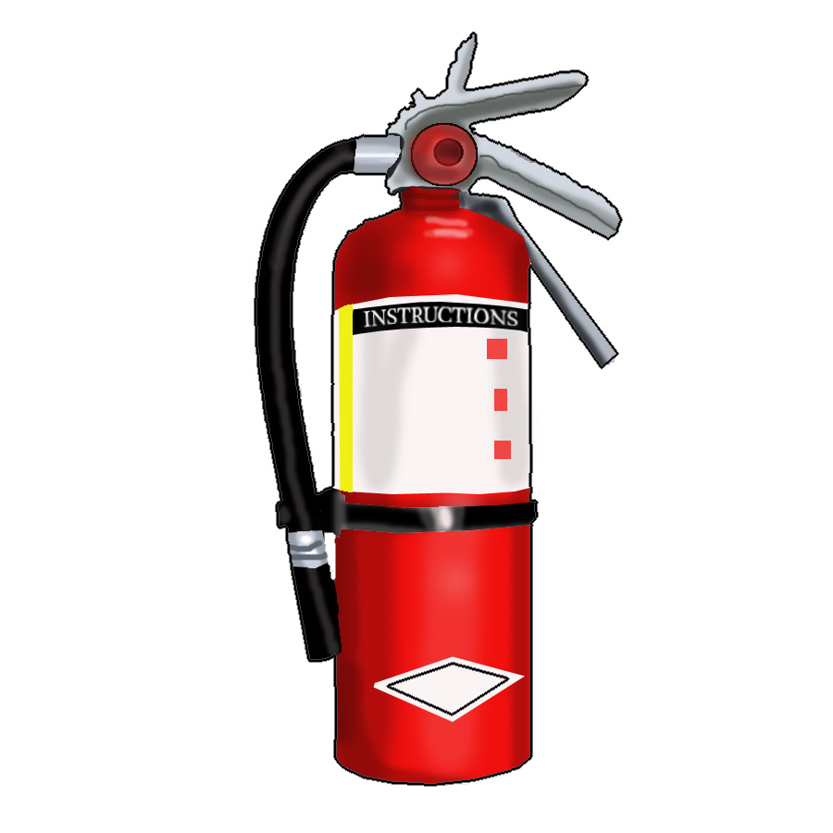
- Store canned goods
  - They last a long time and do not require special storage (be sure to have a can opener)
- Keep a working flashlight and fire extinguisher
- Make sure that smoke alarms and carbon monoxide monitors are up to date and working
- Keep extra batteries on hand to replace when needed
3. Important Reminders
- Always lock your door and keep your key in a safe place. Be thoughtful about making copies of your keys
- Be cautious when discarding cigarette butts, hey can easily catch fire
- If you have a gas stove, double check that it is turned off when you are done using it
- Gas leaks have a noticeable odor--if you smell a gas leak call 911
- Remember to keep a list of emergency contacts easily accessible
  - American Association of Poison Control Centers: 1 (800) 222-1222
Any Room
How to Keep Rooms Clean
1. Put things where they belong when you’re done with them.
THE BASICS
- Make this a habit and it will keep clutter down significantly.
- Throw out stuff that you don’t need anymore. Don’t hesitate to ask others to help with this.
2. Dust the room.
Using a damp cloth, start dusting on one side of the room and make your way to the other end. When you notice that your cloth is too dusty, shake it outside or rinse it with water before continuing to use it. Dust can contribute to allergies.
3. Vacuum or sweep and mop the floor.
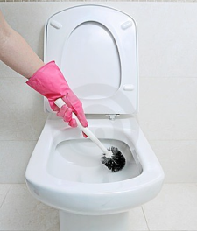
Start on one end of the room and make your way around the room. If you are sweeping, be careful not to step on the pile of trash so that you don’t spread the trash around with your feet.
Bathroom Specific
- Use a paper towel or toilet paper to wipe up any drips from toilet, floor, or counter.
- Wash extra toothpaste down the drain and rinse to keep the sink clean.
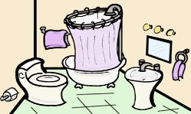
- Clean the outside and inside of the toilet. Wipe the outside first, then use a toilet brush with cleaning product to wipe the inside. Flush.
- Clean the shower. Spray cleaning product on the shower walls and the shower head. Let the product sit for a couple minutes and then rinse with water.
Kitchen Specific
- Wash dirty dishes after you use them. If you have sticky pots or pans, soak them in soap and water and wash them with the next round of dirty dishes.
- Wipe up any drips in the refrigerator. Do this using a slightly damp paper towel to stop any smells.
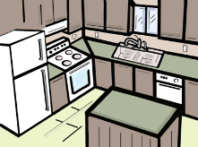
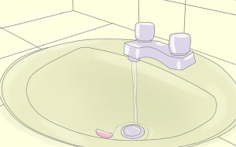
- Take out the trash when it gets full or smelly. Wipe the inside of the trash can if it is starting to smell.
How to buy Groceries and do Laundry
GROCERIES

- Make a grocery list
- Go through your fridge and pantry to see what you have and what you need.
- Plan out your meals for the week and write down the ingredients for each meal. Use a weekly meal planner, like the one in end of this handbook.
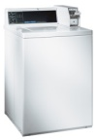
- Think about sizes. If you don’t drink that much milk you should not buy the largest jug of milk.
2. Grocery shopping
- Buy generic store brand products. They are cheaper than name-brand products and similar quality.
- Always look at the expiration date. You don’t want to buy expired or nearly expired food.
3. Store your groceries
- Put your groceries away soon after shopping, especially if you have items that need to be refrigerated.
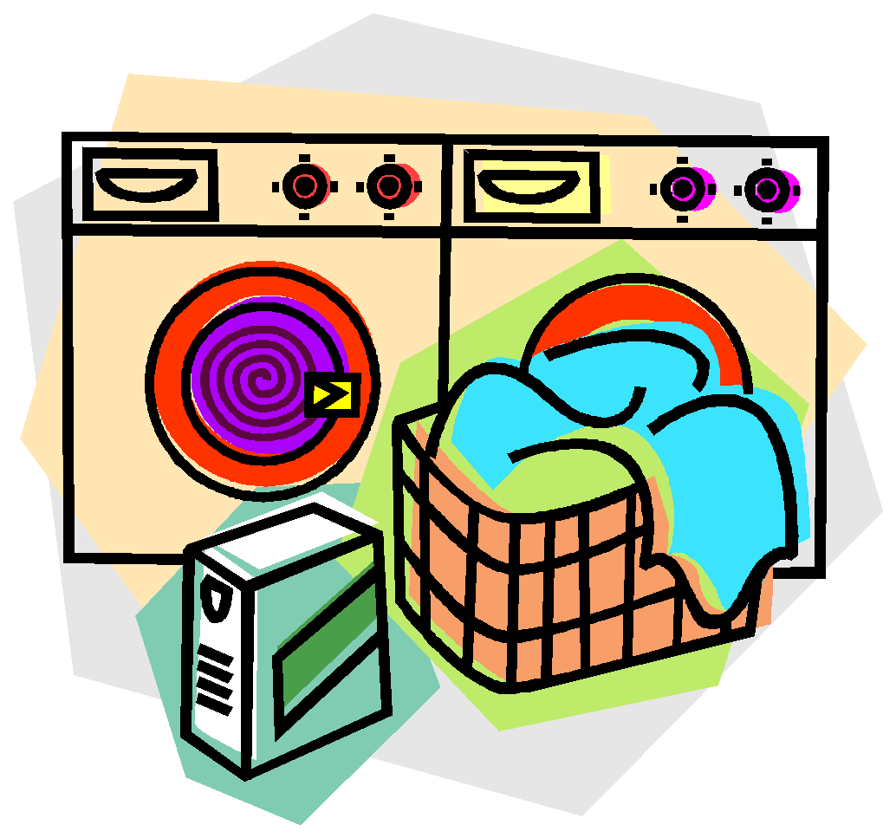
- Freeze products that you will not use for a while, like meat, vegetables, and fruits.
LAUNDRY
- Washing your clothes
- Sort your dirty clothes into piles for white/light colored clothes and dark clothes.
- Before washing, empty out your pockets of any pens, money, or papers.
- After placing your clothes in the machine add detergent to the washing machine. Read the portion chart on your detergent bottle to know how much detergent you should use. Be careful when using bleach because it can harm your skin, eyes, and other clothes.
- Start the washing machine. If you’re using a coin-operated machine, remember to save quarters!
2. Drying your Clothes
- Place your clothes in the drying machine.
- Clean the lint tray before drying.
- Start the drying machine. If you’re using a coin-operated machine, remember to save quarters!
Remember to fold your clothes and put them away after drying them to avoid wrinkles!

How To Keep Track Of
Appointments And Bills
USE A WALL CALENDAR
1. Get a wall calendar for the year with space for writing.
Hang it up in your kitchen area or someplace where you
will be able to easily see it every day.

If you want to have the calendar with you at all times, use a pocket-sized monthly calendar.
2. Cross off the day on your calendar every day.
This will help you keep track of the date. You should do this
every night before you go to bed.
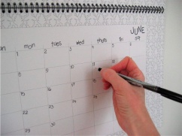
3. Starting to use another calendar.
Hold on to your old calendar and transfer important dates,
like birthdays and appointments to your new calendar.
APPOINTMENTS AND BILLS
1. Use your wall calendar to remember to pay the bills.
Write the due date of your bills on the calendar at the beginning of every month. When you see that you have to pay a bill soon, pay the bill.

2. Add appointments to your calendar.
Whenever you get back home from an appointment, remember
to add the next scheduled appointment to your calendar.
3. Remember birthdays and other important dates.
Add important dates to your calendar as you learn about them.

How To Set And Keep A Budget
And Open A Bank Account
SETTING A BUDGET

1). Keep track of your money and your budget in one place--a notebook works well.
2). Break down to your income into monthly or weekly amounts. This will show you how much you are able to spend per month or week.
3). Figure out your monthly or weekly expenses. Keep track of which expenses change, such as groceries, and which expenses stay the same, such as rent. This will show you what you need to spend per month or week to cover your regular bills.
4). Write down your expenses as you go along. Include the date, expense and cost for the day. Subtract your expenses from your income. Anything left over can be put towards savings.
5). Do not spend money not in your budget. Every week or so, make sure that your expenses are not more money than what you can actually afford. Adjust things if needed.
*For payment assistance programs or getting at Payee visit: http://www.ssa.gov/payee/
OPENING A BANK ACCOUNT

1). Determine your financial needs and goals
2). Consider your options
- If you are looking for an easy way to access cash a checking account is a good option.
- If you are looking to save and build upon your money then a savings account is a good option.
- Both accounts require basic information such as social security number, a photo ID with a signature, and a minimum deposit amount.
3). Before signing anything make sure that you understand any fees that you may be charged.

Credit Unions
- Credit Unions are a great option for individuals with lower incomes. They typically offer higher savings rates and charge lower or reduced fees.

Credit Report and Score
- A credit report contains a history of your credit, loan, and payment history.
- There are three credit reporting agencies: Experian, TransUnion and Equifax. You can check your credit report with each agency for free once a year. Usually the scores are similar, but they can be different. There may be a fee to include your credit score.
- Receiving an annual credit report is important for protecting yourself again fraud and identity theft.
- Your credit score can be used by potential creditors (like banks or landlords) to determine your eligibility for credit cards, loans, and other expenses.

*To learn more about building credit, finding a credit union near you, and monitoring your account see links in the additional information section of the handbook*
How To
Write A Check
STEPS TO WRITING A CHECK

1. Write the date on the line in the upper right hand corner.
There will be a blank space next to or above the word “Date”.
2. Write the name of the recipient of your check.
Do this on the blank spot next to the words “Pay to the Order of”. If the
check is for a person, remember to write their first and last names. If it’s for an organization or company, write the complete name of the organization.
3. Write the amount of your check.
You will find a space for this to the right of a dollar sign. You have to include dollars and cents. Example: write “20.00” for twenty dollars.
4. Write the amount of your check using words.
Do this on the line below “Pay to the Order of” line.
- Examples:
- $20.48 twenty dollars and 48/100
- $20.00 twenty dollars and 00/100
Draw a line running the end of what you’ve written to the end of the line.
5. Sign your name on the line in the bottom right corner.
If you don’t sign your name, the recipient won’t be able to deposit the check.
6. Fill out the memo section on the bottom left hand corner.
This part is optional, meaning that you don’t need to do it if you don’t want to. However, it’s a good idea to write down what the check is for so you can remember the reason in the future.
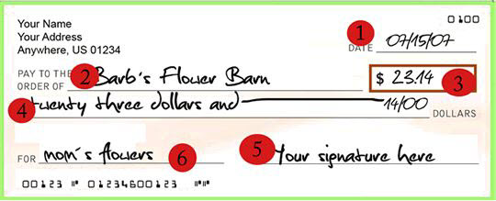
How To Keep A
Weekly Schedule
WHY THIS IS IMPORTANT
1. It will help you form new habits.
It takes time and patience to get used to living on your own. Keeping a weekly schedule will help you form habits to help manage the upkeep of your new apartment.

2. It will help make your chores easier to do.
Instead of doing all of your chores on one day you can spread them out so that you only have to do a little bit each day. Here is an example of how a weekly schedule for your chores can look like:

Sunday | Monday | Tuesday | Wednesday | Thursday | Friday | Saturday
Do laundry | Clean the kitchen | Make a shopping list | Go grocery shopping | Clean the bathroom | Clean the living room | Clean the bedroom

3. It will give you more control of your time.
Keeping a weekly schedule will not only help you manage your time better, as well as give you more control of your time.

4. Plan your week every Sunday.
Every Sunday, either in the morning or in the afternoon, take the time to write down what you want or need to do that week. Include chores, appointments, and bills. And if you can, even include the time you want to do each thing.

5. Cross off everything you complete.
As you complete the things on your weekly schedule, cross them
off with a pen. And, if you don’t get something done, don’t worry.
Just write it down on the following day and try to get it done.

How to get a photo ID
WHY IT IS IMPORTANT
- A photo ID serves as an official form of identification that allows you to prove who you are, your age, and will help and with other benefits.
REQUIRED STEPS
You can obtain a photo ID at the Registry of Motor Vehicles (RMV). Visit http://www.massrmv.com/BranchMap.aspx to locate the RMV closest to you.
Requirements:
- Be at least 14 years of age
- Cannot not hold a valid license in any state
- Must be a resident of MA
What to bring:
- Document proving date of birth (e.g. Birth certificate, veteran’s discharge)
- Document proving signature (e.g. canceled personal check, social security card)
- Document proving Massachusetts residency
  - If you do not have a place of residency you can bring a letter on shelter or other program stationary signed by a case manager. The letter should include your name, SSN, other identification showing that you are without a permanent residence, information indicating where you are currently staying, and a statement from the case manager that they can confirm the facts in the letter.
- A Social Security Number (SSN)
- Completed application. The application form is available at any RMV, or you can download it online from http://www.massrmv.com/rmv/forms/index.htm
- Present application and $25.00 (check or money order only) fee in person to any RMV full service office

Note: *All documents must be originals. Photocopies will not be accepted*

If you are lacking proof of identity, you can get an unofficial picture ID from St. Francis House (39 Boylston St. 4th floor) on weekdays from 10am-11am. You can often use this unofficial ID plus a letter from the shelter or transitional programs as proof of identity.

If you are a Veteran:
- In order to have veteran’s status displayed on your photo ID you need to bring a DD-214 or DD-215 showing an honorable discharge or an honorable discharge form. There are no additional fees to have a veteran’s indicator on your MA ID card.
How To Get
A Library Card
GETTING A LIBRARY CARD
1. Go to a branch of the public library.
Go to http://www.bpl.org/general/hours.htm to find the library in your neighborhood, along with the address and hours.
2. Bring a photo ID.
Your ID should have your full name, present address and signature.
If you do not have a photo ID with the needed information, bring
(1) a letter that came to you in the mail OR a signed copy of your lease, and (2) a photo ID that has your name and signature.

3. Don’t share your library card with anyone.
If you lend someone your library card, you will be held responsible for anything that is checked out with it.
PROGRAMS AND EVENTS

1. Free Computer Classes.
Free computer classes are available at different library locations throughout the city. For more information, talk to someone at the “Information” desk at your local library OR visit the webpage http://bpcc.org/class-schedules.
*Most classes are taught by an in person instructor*

2. Free Events, like concerts and talks.
There are a lot of free events available through the Boston Public library, from concerts to talks to a program for senior citizens. Go to the webpage http://www.bpl.org/programs/calendar.htm to see the calendar of events.
For more information about resources you can find at the public library, please visit their website: http://www.bpl.org

How To Set-Up
An Email Account
GMAIL ACCOUNT
1. Open the Gmail webpage.
Go to gmail.com and click on the blue “Create an account” hyperlink.

2. Come up and write down a username.
If your username is not available use a different one.

3. Fill out the rest of the required information.
This includes a password, your date of birth, and your location.

4. Prove you are not a robot.
Before selecting your current location, you have to do the verification code.
** press on the volume button
if you’re having a hard time
reading that code so you can
hear it.

5. Agree to the privacy policy and click next step.
Do this if you agree to Google’s terms in the privacy policy. After you press “next step” you will have to press it one more time.

You can use your Gmail account to communicate with other people you know, to contact someone for a job or to be contacted for a job, and to communicate with your PCP. To write an email, press on the red button on the top left hand corner of the page after logging (using gmail.com) in to your email account.

How to be informed about your criminal record
Criminal Offender Record Information (CORI)
- A CORI is a person’s criminal record history.
- Even criminal cases where you are found ‘not guilty’ will appear on your CORI.
- Many employers, landlords, volunteer organizations, housing and licensing screeners can see some or all of the information on your CORI, or will ask to see it.
BECOME INFORMED-REQUEST A COPY OF YOUR CORI
- You can request a copy online, by mail, or call the Department of Criminal Justice Information Services (DCJIS) at: 617-660-4640, located at: 200 Arlington Street
Suite 2200, Chelsea, MA 02150
- Online:https://icori.chs.state.ma.us/icori/ext/global/landing.action?page=1&bod=1423252334442&m=presentLanding
- Link to form: http://www.mass.gov/eopss/docs/chsb/personal-access-form-v2-20121228.pdf
- You will need to submit a payment of $25 (check or money order only). If you cannot afford the payment visit:
  - http://www.mass.gov/eopss/docs/chsb/affidavitofindigency.pdf
- Once you receive your record, check it for mistakes.
- Knowing what is on your on CORI will help you be prepared for situations where someone may ask you about your record. You can explain mistakes and bring other character references.
SEALING OR CORRECTING YOUR CORI

- A CORI can be sealed. After your record is sealed most employers and CORI requesters will not find out about your sealed records.
- There are two ways to seal your CORI, both of which are free:
- An administrative process by mail.
  - The needed form can be accessed online at: http://www.mass.gov/courts/probation/sealingpetition.pdf
- In person by a judge.
- Laws differ by state. Sealing your CORI in Massachusetts only seals it for charges within the state.
- Records that can be sealed include:
- Cases where you were not found guilty, or cases where charges were dismissed or dropped.
- Most criminal records can be sealed after a waiting period: a minimum of 5 years for a misdemeanor and a minimum of 10 years for a felony. Some can be sealed by a judge with no waiting period.
- Some types of convictions including, certain firearms offenses, perjury, witness intimidation, state ethics act violations and sex offense cases cannot be sealed.
- Juvenile records can be sealed at the same time that you seal your CORI.
- Criminal justice agencies, and certain education and departments that work with children have access to sealed record information during the hiring process.
*For more information on criminal record rights call:
Greater Boston Legal Services at: (617) 371-1234 or Legal Advocacy and Resource Center (LARC) at: (617) 603-1700 or 1-800-342-5297
FOR MORE INFORMATION AND ADDITONAL RESOURCES ABOUT…
- Grocery Store (and other Stores) Coupons
  - Look inside your Sunday newspaper
  - Go to RetailMeNot.com
  - Go to CouponMom.com
  - Go to CouponCabin.com
  - Go to Coupons.com
- Healthy Eating
  - Go to http://www.choosemyplate.gov/
    - And for information about eating healthy on a budget, click on the “Healthy Eating on a Budget” button the left-hand menu (or go to http://choosemyplate.gov/budget/index.html)
- Cleaning and Organizing Your Apartment
  - Read articles found in the webpage of wikiHow here: http://www.wikihow.com/Category:Personal-Space
- Dealing and Managing With Stress or Anger
  - Talk to your Primary Care Provider or Psychiatrist
  - If you need to talk to someone immediately, go to the BMC clinic at JYP (780 Albany St.) during Open Access Therapy appointments
    - Mondays 9:00am-10:00am, Wednesdays 10:00am-12:30pm, Thursday 9:45am-11:45am
- YMCA and Fitness Options
  - Talk to your Case Manager
  - Visit the YMCA’s website here: http://www.ymcaboston.org/membership/financial-assistance
- Getting a Charlie Card
  - Visit the MBTA website here: http://www.mbta.com/fares_and_passes/charlie/?id=5592
- Opening a Bank Account
  - Visit: https://quicken.intuit.com/support/help/budgeting-basics/finances-101--opening-your-first-checking-account-/INF24298.html
  - Or visit: https://www.wellsfargo.com/goals-going-to-college/first-account/
- Managing Debt
  - Visit: http://www.consumer.ftc.gov/articles/0150-coping-debt
- Resources for Elderly Individuals
  - Visit: http://www.cityofboston.gov/elderly/
  - Or visit: http://www.massresources.org/senior.html
- Death Arrangements
  - Visit: http://www.funeralwise.com/plan/how_to/
- Finding a Credit Union Near You
  - Visit: http://www.mycreditunion.gov/pages/mcu-map.aspx
- Receiving Your Annual Credit Report
  - Visit: https://www.AnnualCreditReport.com
- Credit Scores
  - Visit: http://www.consumerfinance.gov/askcfpb/315/what-is-my-credit-score.html
- Taxes
  - Visit: http://www.irs.gov/Individuals/Free-Tax-Return-Preparation-for-You-by-Volunteers

