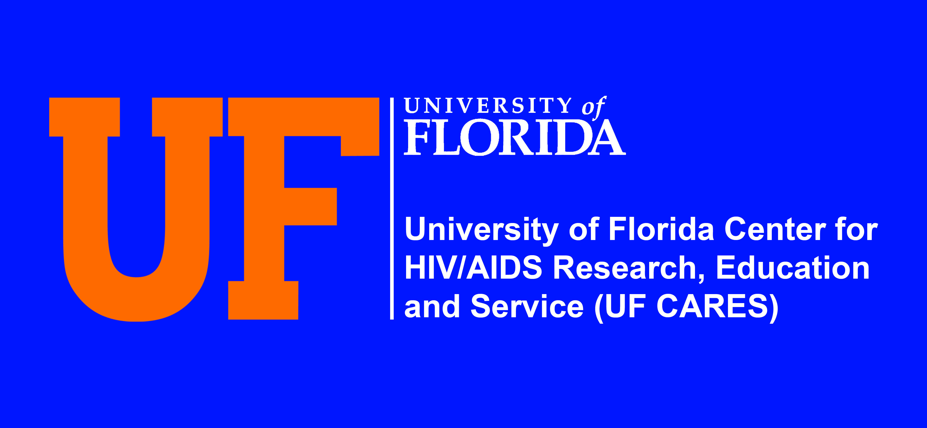
Housing Process for Path Home Clients
  - Comprehensive Case manager Receive Referral from UF Cares Medical Case Manager

  - Comprehensive Case manager has 72 hours to make contact with client to schedule an intake appointment

  - After Comprehensive Case manager makes phone contact with client he/she schedules client an appointment to complete the client checklist and intake paperwork to identify client needs

  - Comprehensive Case manager meets face to face with client to determine his or her needs. During the intake process. Case manager is able to identify client needs such as food, clothing, housing, picture ID., Social Security card, and food stamp assistance, SSI Disability linkage to mental health and substance abuse treatment, and birth certificate. Case manager is also able to identify if the client has an income or need assistance to with creating a resume to find employment.

  - After Comprehensive Case Manager assesses the client needs he/she can be referred by case managers to receive assistance from agencies within the community. These needs can be identified as food pantries. River Region Drop in center provides clothing for clients.

  - Comprehensive Case manager informs Peer Navigator of what client needs. Peer Navigator can assist client with picture ID, Social Security Card, transportation needs, and birth certificate.

  - If a client has an income Comprehensive Case manager assist client with finding housing within the community. When client has identified what apartment he/she will be living in; case manager, client, and landlord negotiates a monthly rental amount based on client income and determine client rental deposit amount to move into housing.

  - Comprehensive Case manager transports client to Jacksonville Electric Authority to get a printout of how much the electric deposit will be. Comprehensive Case manager will complete a referral for rental and electric deposit assistance to receive HOWPA funding from agencies in the community.

  - An appointment is scheduled for client to receive HOWPA funding with NFAN, Catholic Charities, or City Welfare. After receiving funding a Promise to Pay letter is faxed to the landlord and the client discusses with landlord a date he/she can move into housing. If client needs furniture a voucher is given to client by case manager.

