Sample Plan of Care (Parent View)
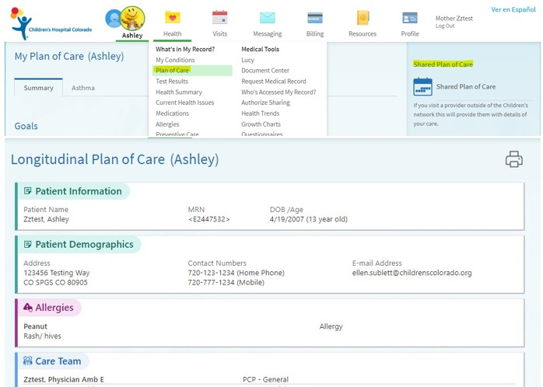

Sample Role Clarification (Parent View)
