* Hi I am Sam. I liked to be called **Sammy**.
* I am 10 years old.
* My birthday is July 3, 2009

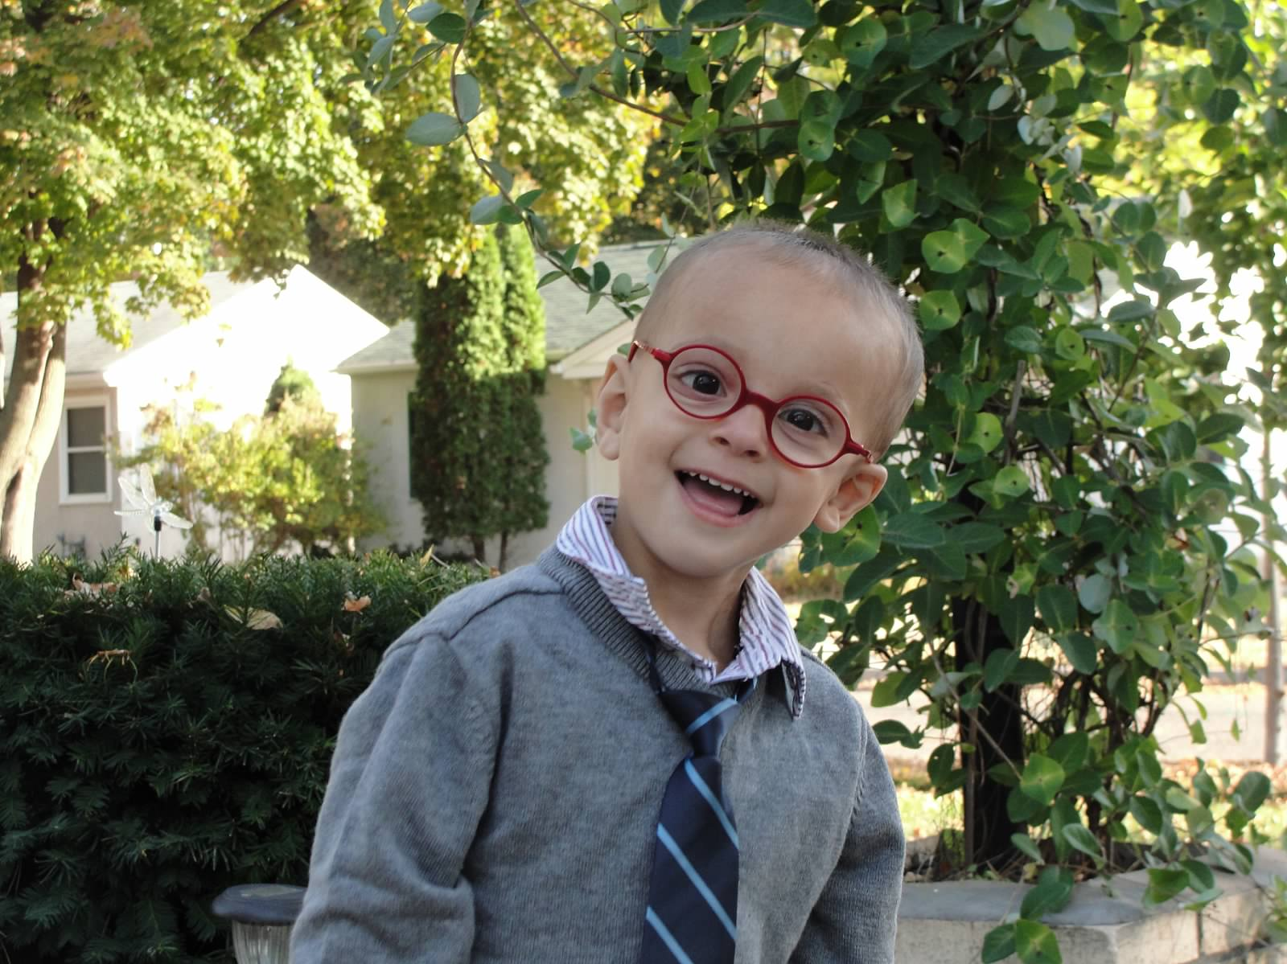

Example ***All About Me*** document

**What Works / Things I Like**

* Giving me choices on what to play with.
* Asking me to use my talker/communication device
* I like to build stuff. Duplos and blocks are my favorites.
* Speaking directly to me
* Sensory breaks
* Praise for my achievements

**What I’m Working On / What’s Important to Me**

* Communicating with my voice
* Pain reduction
* Staying calm
* Increasing my weight
* Using my hands
* Going to school as much as I can

**What Doesn’t Work / Things I Don’t Like**

* Touching me without asking
* Lots of people in the exam room
* Bright lights in my eyes
* Being rushed or sudden change in activity
* Assuming I don’t understand you

**Hopes & Dreams / My Best Life**

* I want to be able to stay living at home.
* I want to go play outside in my yard as much as possible.
* I want people to understand me when I talk
* I want to stop vomiting and no more tummy pain.
* I want to go to school and have lots of friends.

**My Family and Other Important People**

* I live with my Mom Rhonda, my Dad Bill, my Brother Will and my guinea pig Chatterbox.
* My mom’s friend Becky is really close to me. She helps me a lot.
* I love to spend time with my Grandma and Grandpa.

**My Strengths**

* I understand everything you tell me.
* I am a curious little boy, who learns by touching things.
* I have a silly sense of humor and like it when you make me laugh

Note: This is a fictional description, for example purposes only

**Date Created/Updated: 10/17/2019**