Patient Touchpoints – Children’s Comprehensive Care Clinic, Austin, TX

Results
Patient 1: 16-year-old female with spastic quadriplegia, scoliosis, acute on chronic respiratory insufficiency on BIPap at night, seizures, dysphagia, gastrostomy dependent

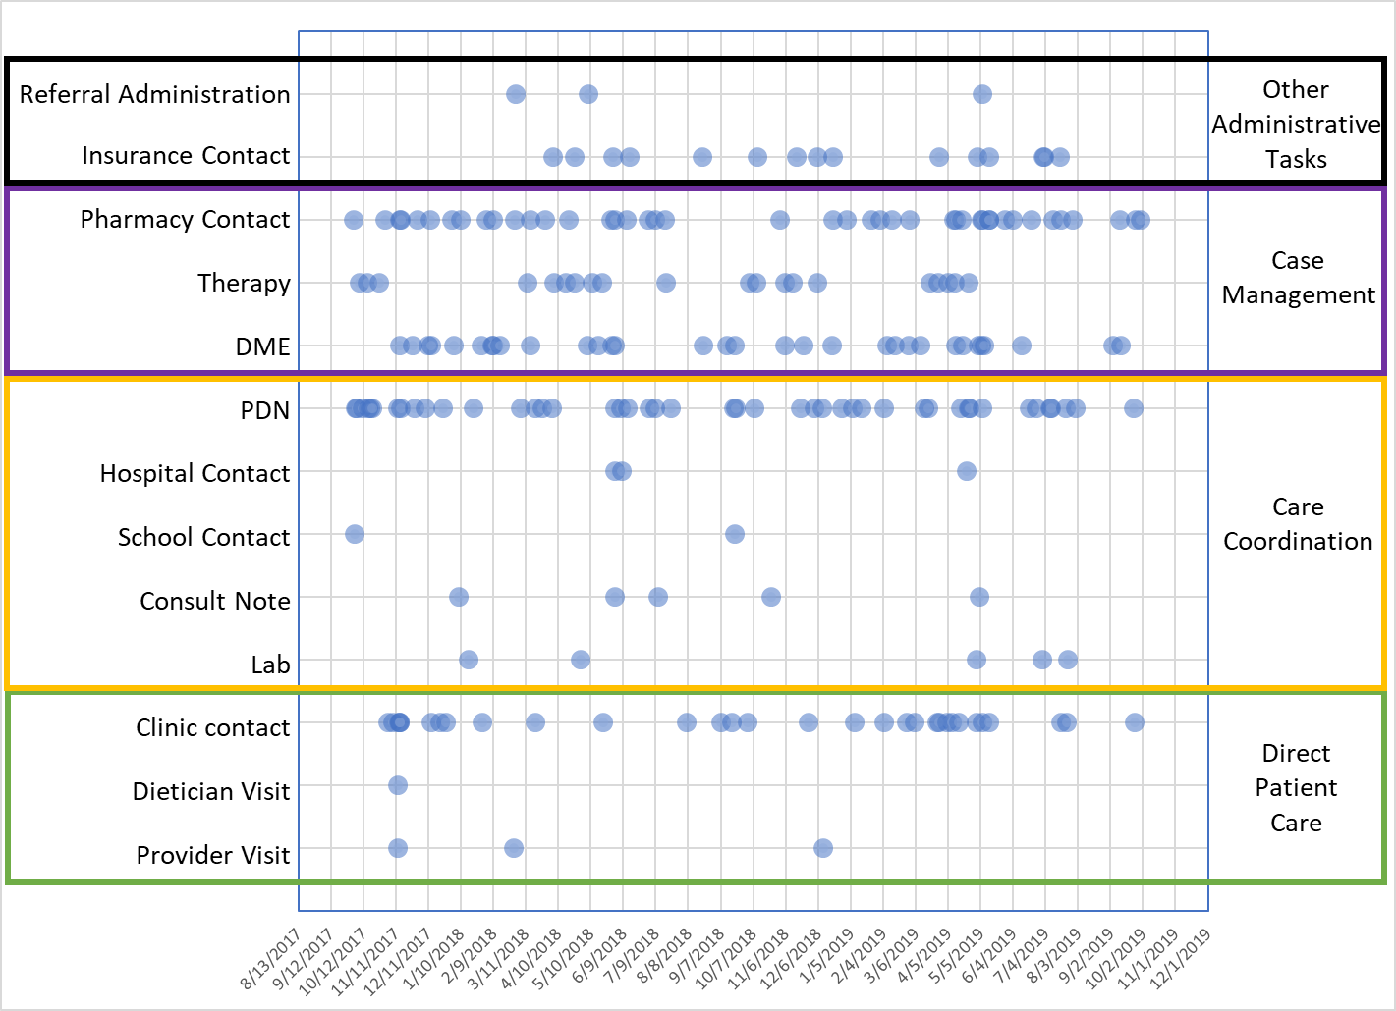
Patient 2: 4-year-old male born with an obstructive craniopharyngioma, tracheostomy and ventilator dependent, gastrostomy dependent.
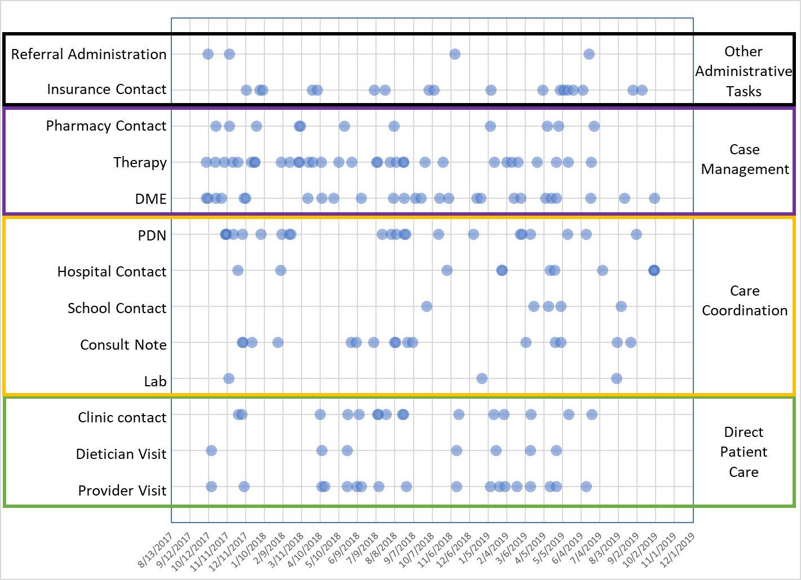

Patient 3: 3-year-old male with Spina Bifida, neurogenic bowel, gastrostomy dependent, neurogenic bladder, catheterization dependent, hydrocephalus with a ventriculo-peritoneal shunt, Obstructive Sleep Apnea, Tracheostomy dependent.
