UW Health-AFCH Pediatric Complex Care Program Shared Plan of Care
For @NAME@
@TODAYDATE@

“Who Am I?”/Patient Description: ***{One or two line description of patient - preferably patient/family helps create this.}

PLANS OF ACTION:
{copy and paste goals and to-do list from AVS}

MEDICAL SUMMARY:
Care Team:
@CARECOORD@
@PTNAMEANDTITLE@ is enrolled in the Pediatric Complex Care Program. See "Medically Complex Patient" in Problem List.
PCCP Team: 1-***/2-***/***RN/***CCA

Community Supports/Agencies:
***name of person, ***name of agency, ***contact information

@PREFPHARMACY@

To reach the Pediatric Complex Care team:
Patients/Families:  Call 608-263-6420 24 hours/day. Use option 3 during business hours. | UW Health Teams:  Use UW Paging to reach PCCP team members or provider on call. | Provider-to-Provider:  Call UW Access Center at 1-800-472-0111 | For RN, SW, or CCA: call 608-263-6420, option 3 during business hours.
Peds Complex Care Fax Number: 608-890-9678
Primary Care Provider: @PCP@
Specialty Providers: ***

@PROBLEM2@

@MEDSCURRENT@

FAMILY INFORMATION & PREFERENCES:
@SOCDOC@
@PATIENTFIRSTNAME@ lives with {parents' names}, *** and {PETS(MCHC UW TEAM):11712} in a {Housing :28847}¹. @PATIENTFIRSTNAME@ enjoys ***.
Transportation:
Family describes ***{FAMILY:11988}² and {SUPPORT PERSONS:12220}³ as source(s) of support. @PATIENTFIRSTNAME@ receives {private duty nursing, personal care worker services, respite care services}.
Religious or cultural considerations:
Preferences about sharing medical information/decision-making:
Parental occupation(s):
Daycare/School: @PATIENTFIRSTNAME@ attends *** school (*** School District) and has {School Educational Supports:32506}⁴ and receives {Thearpy Type:34994}⁵ there.
Appointment Scheduling Preferences {days of week, number of visits/day}

1 | 2 | 3 | 4 | 5

OTHER IMPORTANT ITEMS: {DELETE ANYTHING THAT IS NOT RELEVANT EXCEPT GOALS AT THE END}
{Other Important Items:37712}
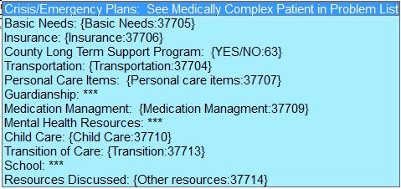
Goals for working with the Pediatric Complex Care Program...assistance with medical co-management, medications, feedings, complex scheduling, insurance issues, referrals to community resources, care coordination, help with transitions and other needs we can impact.

Note: Anything highlighted in yellow provides detail about other dot phrases and/or other items pulled into this note from other parts of the EMR.

